**Wall magizne**

**College of Engineering and Management,Kolaghat**

**By Santu Jana(CSE/21/L146) august,2022**

**AI BASE CHATBOTS**

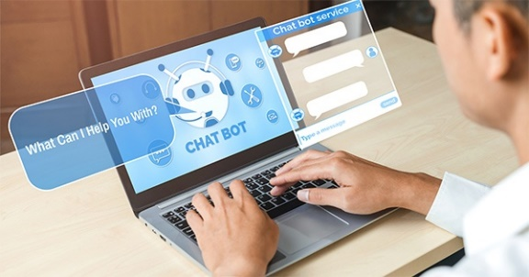

**What Are Chatbots?**

Chatbots – also known as “conversational agents” – are software applications that mimic written or spoken human speech for the purposes of simulating a conversation or interaction with a real person. There are two primary ways chatbots are offered to visitors: via web-based applications or standalone apps. Today, chatbots are used most commonly in the [customer service](https://www.wordstream.com/blog/ws/2019/05/08/live-chat-rulebook) space, assuming roles traditionally performed by living, breathing human beings such as Tier-1 support operatives and customer satisfaction reps.

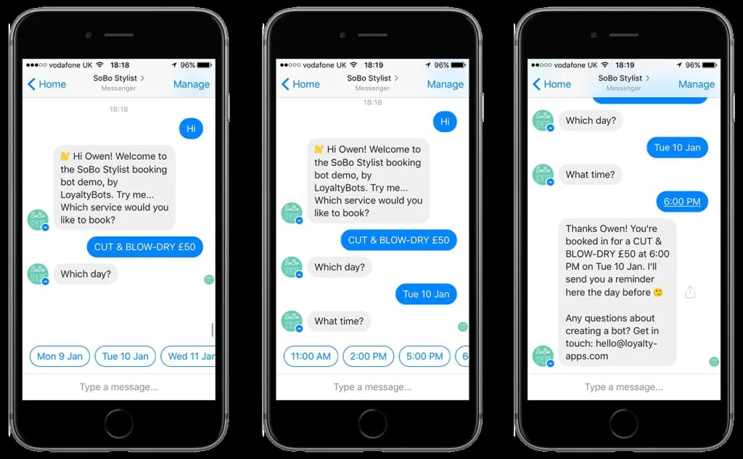

Conversational agents are becoming much more common partly due to the fact that barriers to entry in creating chatbots (i.e. sophisticated programming knowledge and other highly specialized technical skills) are becoming increasingly unnecessary.

Today, you can make your very own chatbot that you can use in [Facebook Messenger](https://www.wordstream.com/blog/ws/2018/12/13/facebook-messenger-bots), for example – all without a pricey Computer Science degree [or even much prior coding experience](https://www.wordstream.com/blog/ws/2015/01/02/learn-to-code-free) – and there are several sites that offer the ability to create rudimentary chatbots using simple drag-and-drop interfaces.

**How Do Chatbots Work?**

At the heart of chatbot technology lies natural language processing or NLP, the same technology that forms the basis of the voice recognition systems used by virtual assistants such as Google Now, Apple’s Siri, and Microsoft’s Cort*ana.*

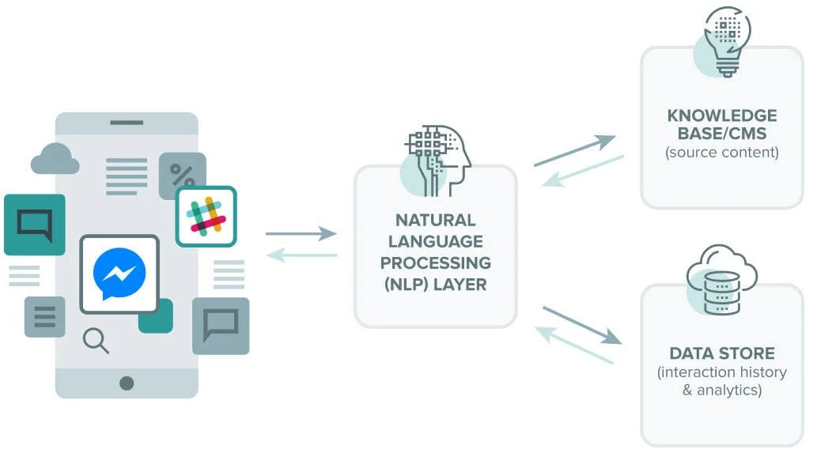

Chatbots process the text presented to them by the user (a process known as “parsing”), before responding according to a complex series of algorithms that interprets and identifies what the user said, infers what they mean and/or want, and determine a series of appropriate responses based on this information.

#### The Chatbots of the Future

The first generation of chatbots served a useful purpose in making customer service more accessible. However, their technological limitations and inability to handle complex human language, intents, and other aspects of communication have paved the way for [conversational AI](https://www.tangentia.com/automation/artificialintelligence/tia-chatbot/).

Additionally, markets like [intelligent virtual assistants (VA)](https://www.tangentia.com/ai-powered-chatbots-in-higher-education-a-positive-impact-for-students-and-administrations/) also have been increasing their reach for AI technology and AI-powered chatbots. Like consumer-focused enterprises, conversational AI makes it possible for each student to individualize their on-campus and academic experiences.

The increased accessibility, personalization capabilities, and language comprehension using this technology have completely changed the game of VA and the future of chatbots.